Icon Design Guidelines, Android 2.0

1 Providing Density-Specific Icon Sets(提供特定的 icon集合)
In general, the recommended approach is to create a separate set of icons for each of the three generalized screen densities listed in Table 1, below
一般来讲，推荐如下尺寸的icon集合，对应三种密度屏幕。
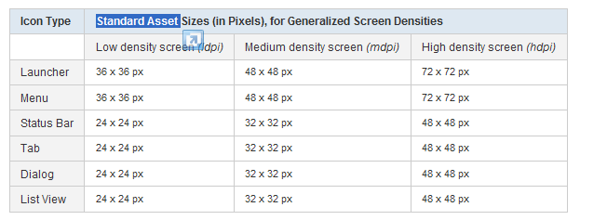

2 Launcher Icon(手机home屏上显示的图标)
The system manages the scaling of all Launcher icons so that they rendered at a uniform height and width
系统会把icon缩放成统一尺寸的宽高。
The actual pixel dimensions of the rendered Launcher icons on any given device varies, based on the size and pixel-density characteristics of the device's screen。
根据不同设备的大小和像素密度特性，icon缩放的实际像素尺寸并不相同。

3 Style
The launcher icons that you create should follow the general style principles below
Icon建议如下原则：
- Clean and contemporary:Launcher icons should be current and sometimes quirky, but they should not appear aged or ragged. You should avoid overused symbolic metaphors whenever possible.
干净清晰并时尚：icons应该是有流行性的有事甚至是古怪的，但是不应该是古老或者粗糙的样子,任何时候都要避免采用过时的设计。
Simple and iconic:简单并有标志性
- Android Launcher icons are caricatural in nature; your icons should be highly simplified and exaggerated, so that they are appropriate for use at small sizes. Your icons should not be overly complicated.(icon应给简洁抽象，方便在小尺寸中显示，避免过于复杂)
- Try featuring a single part of an application as a symbolic representation of the whole (for example, the Music icon features a speaker).尝试使用应用中的一个有特色并单一功能代替整体做为图标（比如使用一个音乐icon做为一个speaker应该用的图标）
- Consider using natural outlines and shapes, both geometric and organic, with a realistic (but never photorealistic) rendering.考虑使用自然的形状或者轮廓，既可以是几何图形，也可以是生物的现实主义风格的绘制（但永远不要逼真的风格）
- Your icons should not present a cropped view of a larger image.(icons不要是一种从一张大图中裁剪出来的感觉)
Tactile and textured（有触摸感和纹理）:Icons should feature non-glossy, textured material.(icons 应该不光滑，有纹理质感。)
- Forward-facing and top-lit(向前和顶部照明):New for Android 2.0 and later platforms: Android Launcher icons should be forward-facing, with very little perspective, and they should be top-lit.(android 2.0以后版本的icon应该是朝前的，有一点透明，顶部有照明效果)
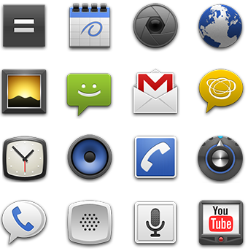

4 Do's and Don'ts
- Android Launcher icons are...
Forward-facing and top-lit, whole, limited in color palette
Modern, minimal, matte, tactile, and textured
Android 的icon应该是 朝前，顶部有照明，完整，使用有限的颜色，风格时尚，较小，有粗糙感，有触感，有纹理的。
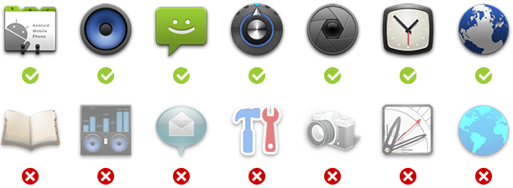

5 Materials and colors(材质跟颜色)
Launcher icons should make use of tactile, top-lit, textured materials. Even if your icon is just a simple shape, you should try to render in a way that makes it appear to be sculpted from some real-world material.
Icons应该使用粗糙，顶部有照明，有纹理的材质，即使是一个简单的图形也应该尝试把他绘制成一个像从一个真是材质中雕刻出来的样子.
The Launcher icons for the platform's default applications use the set of materials shown in Figure 3, below. Your icons can use these materials or you can create new materials.
平台提供的应用icon使用了如下材质，也可以自己设计新的材质
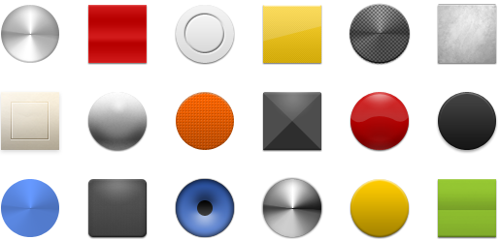

Android launcher icons usually consist of a smaller shape within a larger base shape and combine one neutral and one primary color. Icons may use a combination of neutral colors but should maintain a fairly high level of contrast. Icons should not use more than one primary color per icon, if possible.
Android icon 一般是一个小图形和一个大图型组合起来小图形嵌套在一个大图形里面，采用中性和主要的颜色。
Launcher icons should use a limited color palette that includes a range of neutral and primary colors. The icons should not be over-saturated.
Icons应该使用有限颜色的调色板，调色版是包括中性色和主色的一个范围，icons不要过饱和。
The recommended color palette to use for Launcher icons is shown in Figure 4. You can use elements of the palette for both the base color and the highlight color. You can use the colors of the palette in conjunction with a white-to-black vertical linear gradient overlay. This creates the impression that the icon is lit from above and keeps the color less saturated.
推荐的调色板颜色请参考示意图，base color和highlight color都可以使用该调色板中的元素。
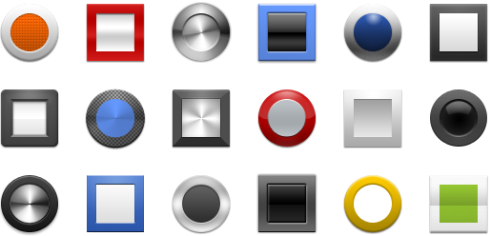

When you combine the materials above with a color highlight from the recommended pallete, you can create materials combinations such as those shown in Figure 5. To get you started, the icons pack includes a Photoshop template file (Launcher-icon-template.psd) that provides all of the default materials, colors, and gradients.
官网里可以下载photoshop的psd文件，提供了所有默认的材质，颜色，渐变。
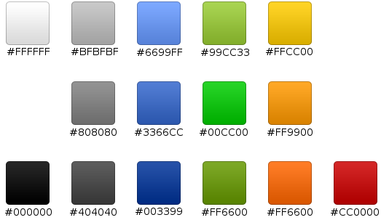

6 Size and positioning尺寸和位置
Launcher icons should use a variety of shapes and forms and those must be scaled and positioned to create consistent visual weight.
Icons会是各种形状和形式，他们被缩放或者重定位后必须是视觉统一的。
Launcher icons should use a variety of shapes and forms and those must be scaled and positioned inside the asset to create consistent visual weight with other。
缩放以后必须和其他icons一样在一个统一的范围(asset)之内。
Figure 6 illustrates various ways of positioning the icon inside the asset. As detailed in the table below, you should size the icons smaller than the actual bounds of the asset, to create a consistent visual weight and to allow for the inclusion of shadows. If your icon is square or nearly square, it should be scaled even smaller.
示意图6展示了几种icon定位在asset内部的方式。Icon应该比asset的边缘还要小，才能创建出统一的视觉现象和阴影。如果icon是方形或者接近方形，他应该可以被缩放到更小。
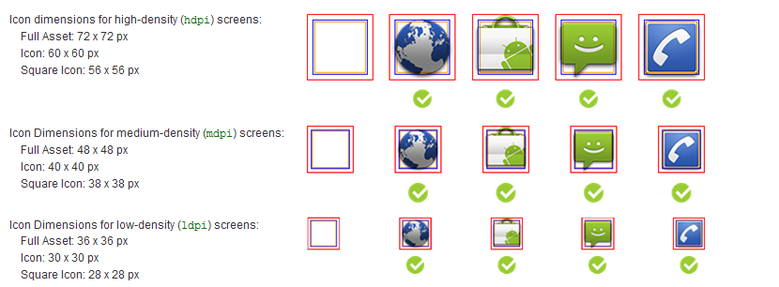
- The bounding box for the full asset is shown in red.红色边框是asset范围
- The recommended bounding box for the actual icon itself is shown in blue. The icon box is sized smaller than the full asset box so that there is space to include shadows and special icon treatments.蓝色框是实际的icon范围，蓝色框尺寸较小可以空出阴影和icon特殊的要求
The recommended bounding box for an icon that is square is shown in orange. The box for square icons is smaller than that for other icons to establish a consistent visual weight across the two types.推荐icon内容在橘黄色方形之内。

7 Using the Launcher Icon Template
使用官方提供的模版创建icon

